Chapter 14, Solution 70.

- 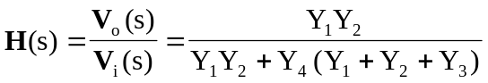
where 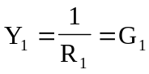, 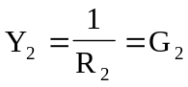, 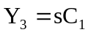, 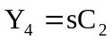.

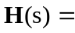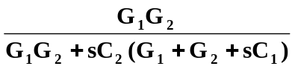

- 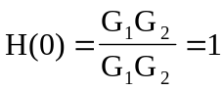, 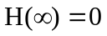
showing that this circuit is a lowpass filter.

